Proposed Solution
Incident Lifecycle Automation in ServiceNow

1. Overview
The proposed solution is a ServiceNow-based incident management process that supports the lifecycle from incident creation through categorisation, prioritisation, assignment, investigation, resolution, and closure. Automation is applied only to steps that are approved, available, and tested in the target instance.

2. Proposed workflow
- Step 1 — Incident creation: an authorised user submits incident details through an available channel.
- Step 2 — Categorisation and priority: the incident is classified and assessed using the agreed category, impact, urgency, and priority rules.
- Step 3 — Assignment: the incident is routed to the appropriate support group and assigned according to the process.
- Step 4 — Investigation: the support agent reviews the incident, updates its progress, and consults relevant Knowledge articles where helpful.
- Step 5 — Related change, if required: if resolution needs a controlled system change, the appropriate Change Management process is followed and linked where supported.
- Step 6 — Resolution: the agent records the resolution details and required resolution information.
- Step 7 — Closure: the incident is closed according to the configured lifecycle and applicable process.

3. Proposed ServiceNow capabilities
- Incident Management: stores incident details, state, priority, assignment, and resolution information.
- Flow Designer: can automate selected workflow steps such as notifications or routing where configured.
- Business Rules: can apply appropriate server-side record logic or validation.
- Client Scripts: can support form interactions and client-side validation where needed.
- Knowledge Management: supports searching and reusing troubleshooting guidance.
- Roles and ACLs: control who can view or modify incident records and fields.
- Change Management: handles controlled changes required as part of a resolution, where applicable.

4. Expected benefits
More consistent incident handling and clearer ownership.
Better traceability of lifecycle status and resolution information.
Potential reduction in repetitive manual actions.
Improved reuse of existing troubleshooting knowledge.
More structured hand-offs when a controlled change is needed.

5. Risks and controls
Incorrect routing or priority: validate rules with representative test cases.
Excessive access: apply role-based access and least-privilege principles.
Unintended automation: test flows and Business Rules in a non-production environment before use.
Incomplete knowledge content: confirm article relevance and access permissions.
Unproven benefits: measure results before claiming reduced resolution times or fewer recurring incidents.

6. Scope boundaries
The solution does not assume external integrations, predictive AI, or production deployment unless these are separately approved and implemented.
The final configuration must reflect the features and permissions available in the actual ServiceNow instance.

4. Incident Lifecycle Workflow
High-level process flow for the proposed incident lifecycle.
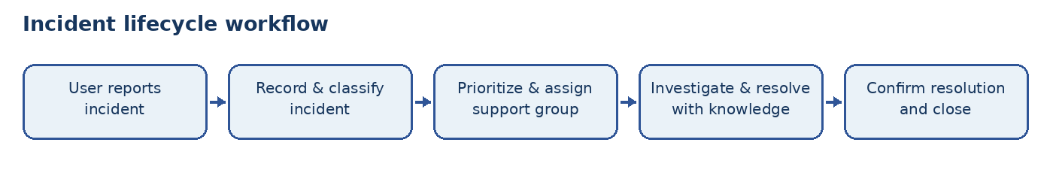

Process Diagram
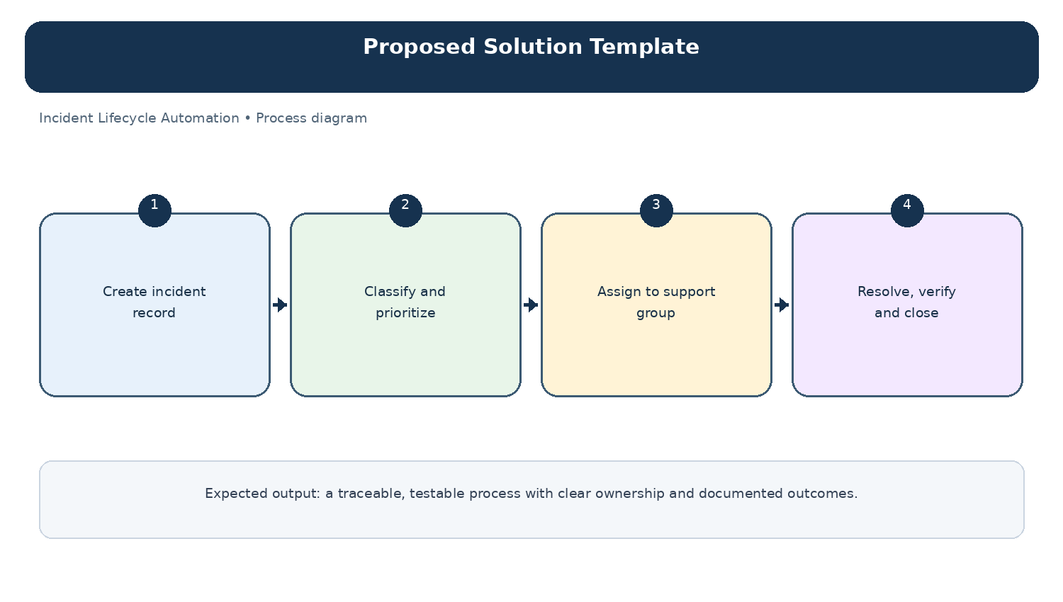
Diagram: Proposed Solution Template — project-specific process overview.

